Date:05.02.2022

**Third Year B. Tech., Sem VI 2021-22**

**Advanced Database System Lab**

**Assignment submission**

**PRN No: 2019BTECS00064**

**Full name: Kunal Santosh Kadam**

**Batch: T2**

**Assignment: 3**

**Title of assignment: Installation, configuration & testing of Oracle 12c EE/18c XE**

1. Download / get setup CD of Oracle Server & Client (Win/Linux).
2. Read and follow the prerequisite for installation and accordingly set the system.
3. If oracle already installed, uninstall it.
4. Install Oracle Server on one machine.
5. Install Oracle Client on another machine.
6. Check the connectivity from Web client and SQL command line. (Note use the hr demo schema)
7. Create new schema/user by your PRN e.g. 2019BTECS00001.
8. Create sample tables in newly created schema / user.
9. Repeat the step 6 for this new schema.
10. Demonstrate the DML on new tables.
11. Create GUI desktop application in Python which will connect to schema created in step 7. Allows to choose available tables. Demonstrate the CRUD operations on selected table.
12. Demonstrate the above program on another machine configured in step 5.

**Introduction:**

A **database management system (DBMS)** is software that controls the storage, organization, and retrieval of data.

The relational model is the basis for a **relational database management system (RDBMS)**. An RDBMS moves data into a database, stores the data, and retrieves it so that applications can manipulate it.

In Oracle Database, a database **schema** is a collection of logical data structures, or schema objects. A database user owns a database schema, which has the same name as the **user name**.

MySQL is released under an open-source license. So you have nothing to pay to use it. MySQL is a very powerful program in its own right. It handles a large subset of the functionality of the most expensive and powerful database packages. MySQL uses a standard form of the well-known SQL data language. MySQL works on many operating systems and with many languages including PHP, PERL, C, C++, JAVA, etc. MySQL works very quickly and works well even with large data sets.

**Procedure:**

**Installation of Oracle 18XC steps:**

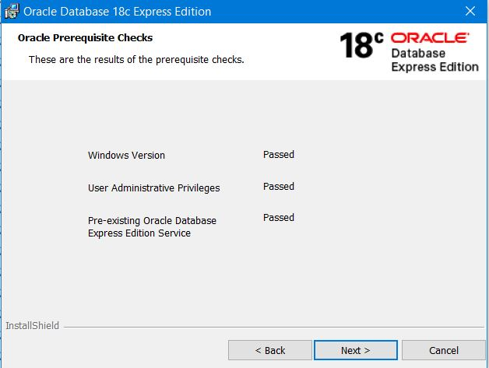

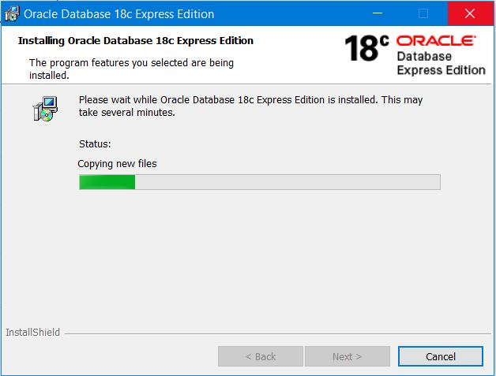

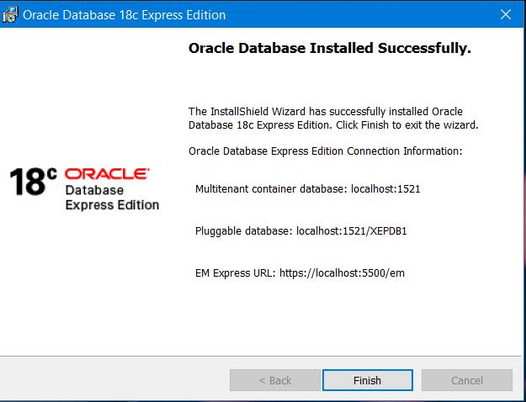

**MySQL Command Line Client**

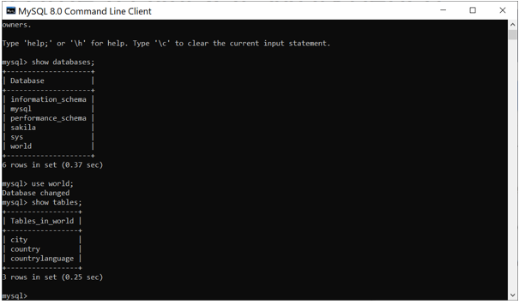

**Oracle Connection with python through XC_oracle**

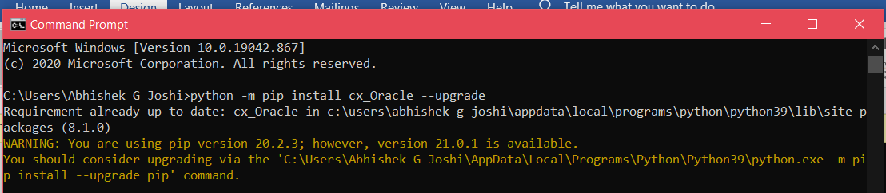

**MySQL Workbench**

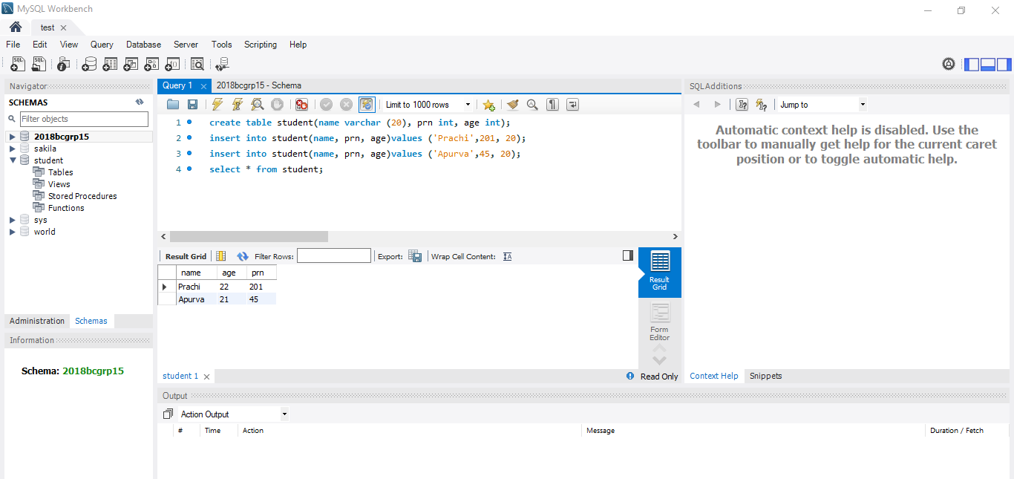

**ORACLE Workspace**

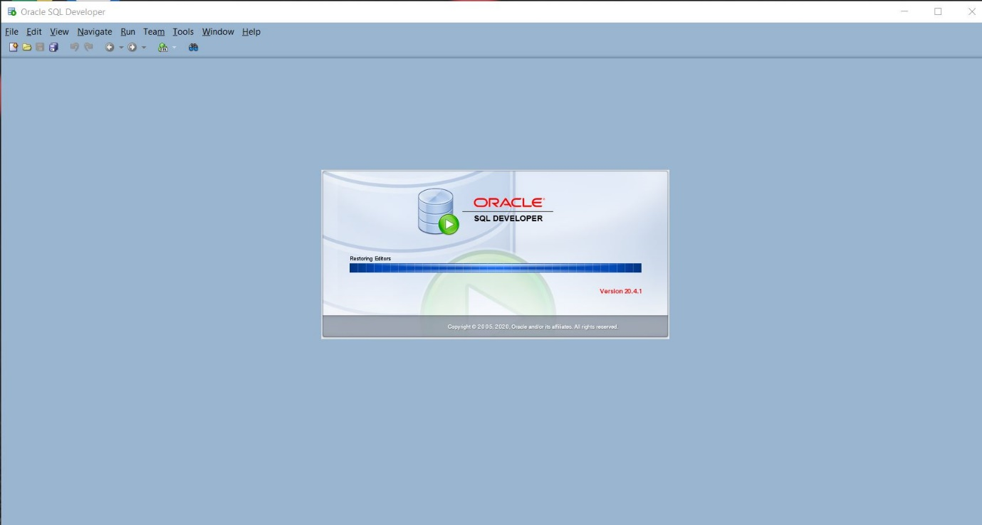

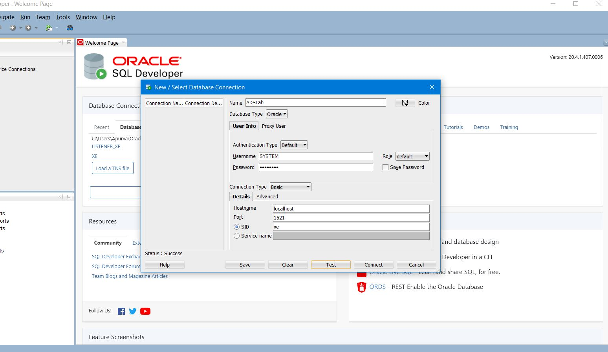

**Making GUI with python and ORACLE server**

1. **Table Creation:**

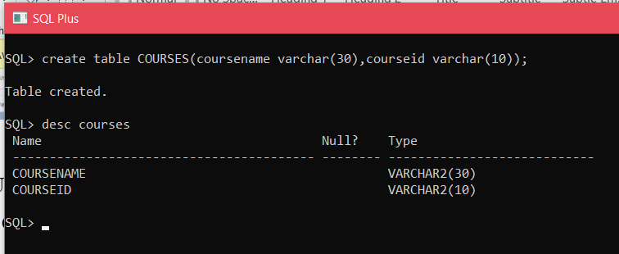

1. **Data Insertion:**

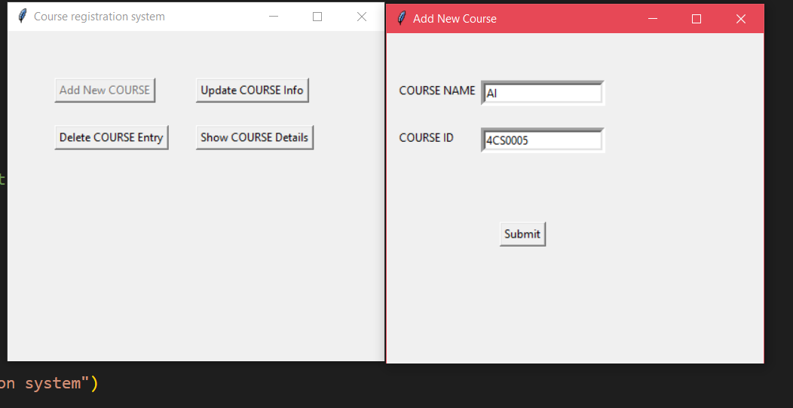

1. **Data Deletion:**

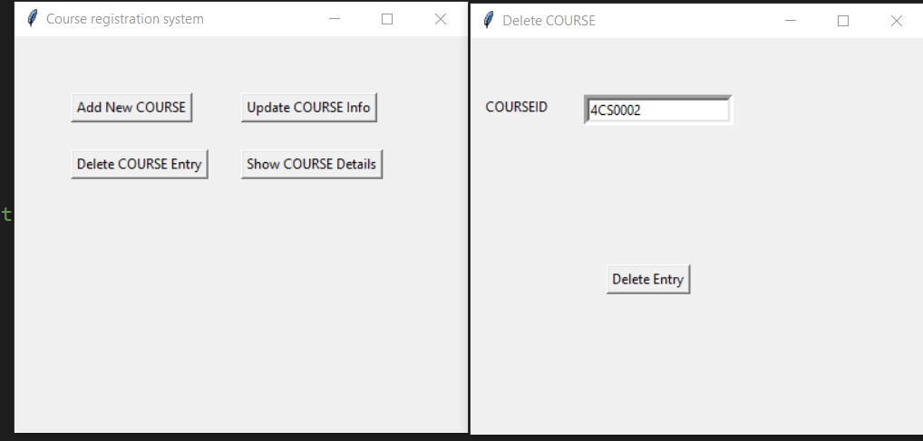

1. **Data Updation:**

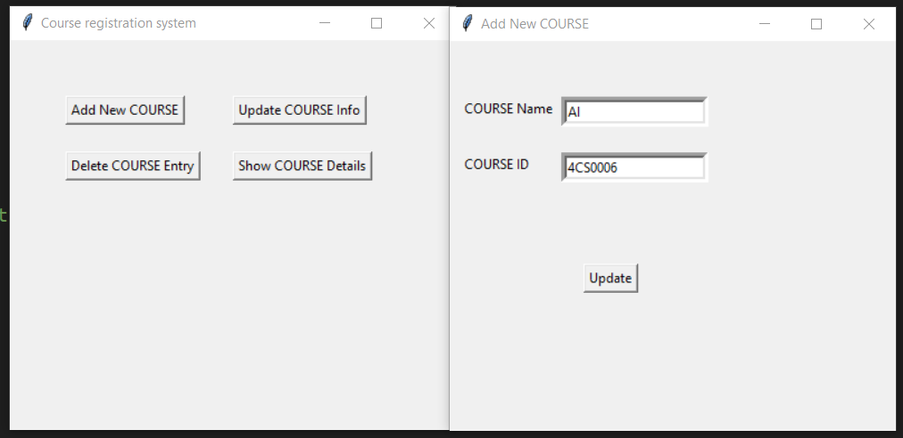

1. **Data Display**

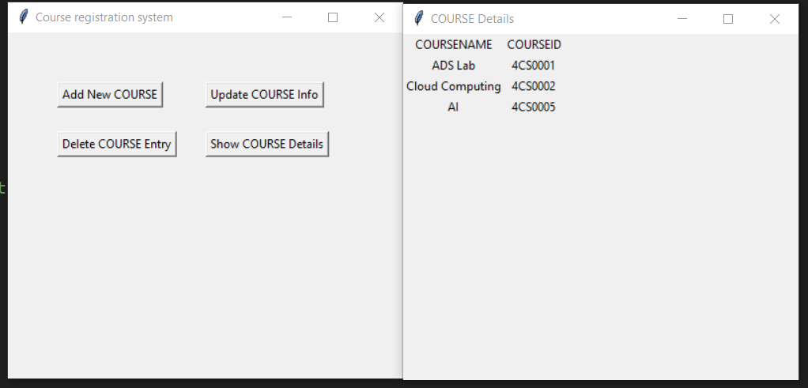

**Making GUI of python with MySQL:**

**MySQL connection:**

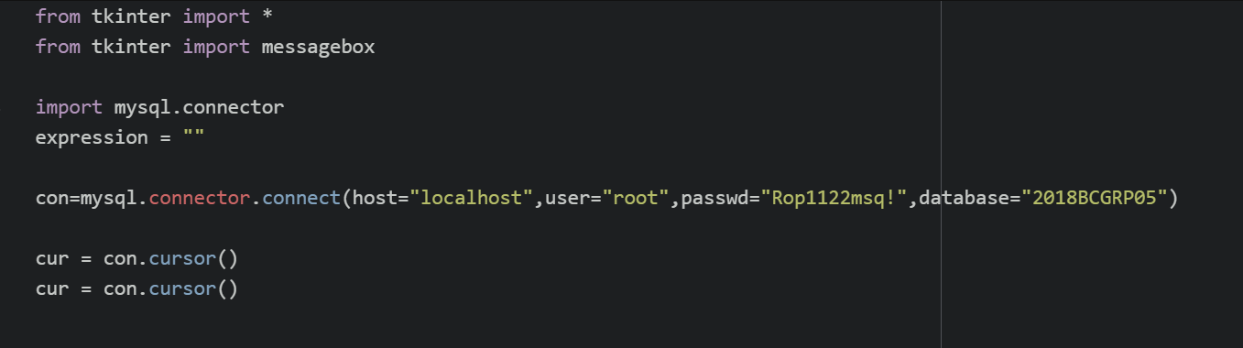

**In shell:**

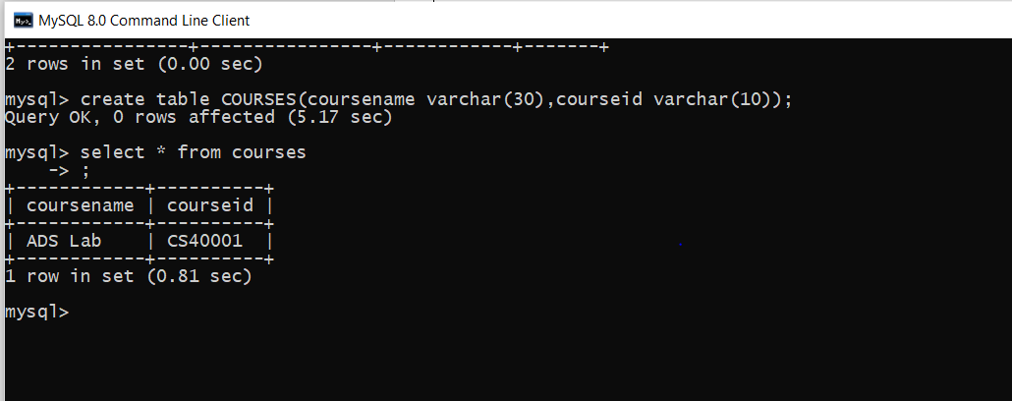

**GUI:**

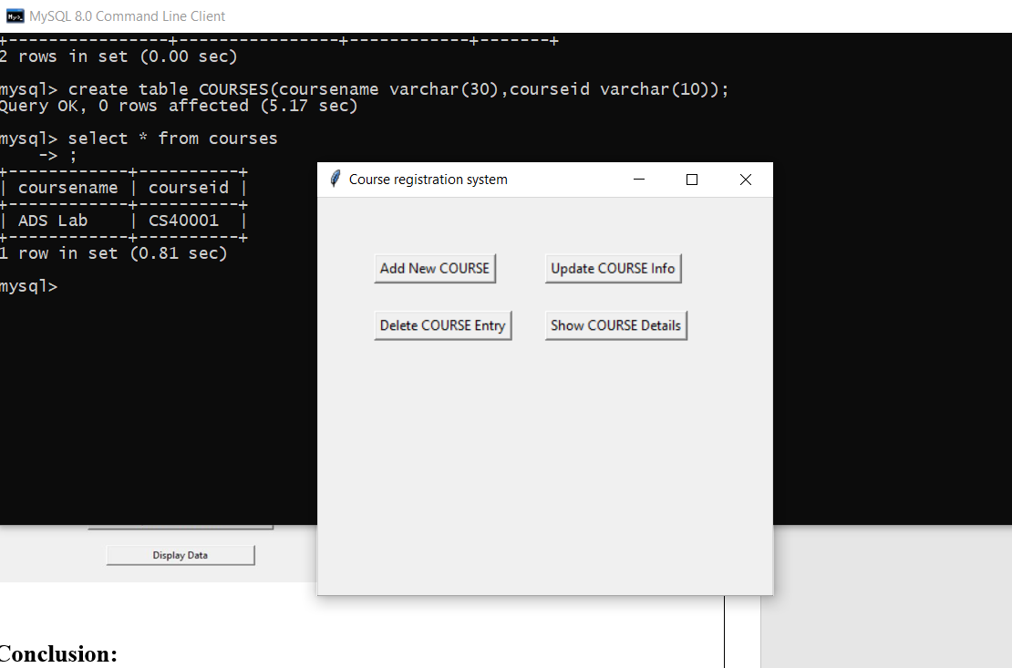

**Installation of MySQL 8.0 Steps**

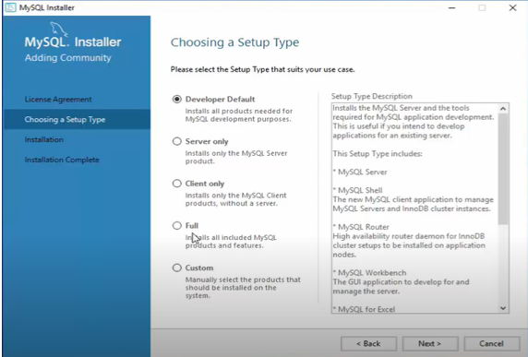

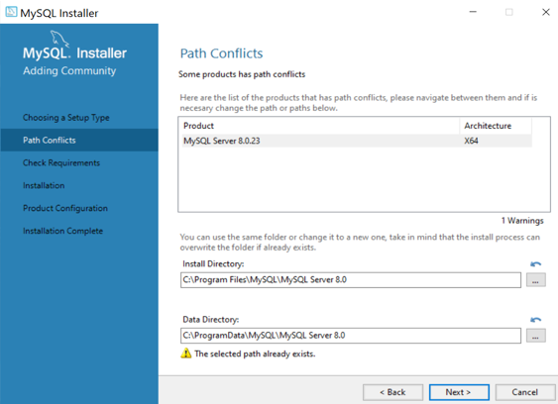

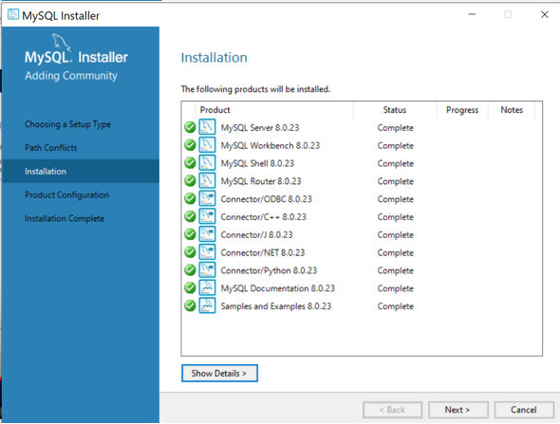

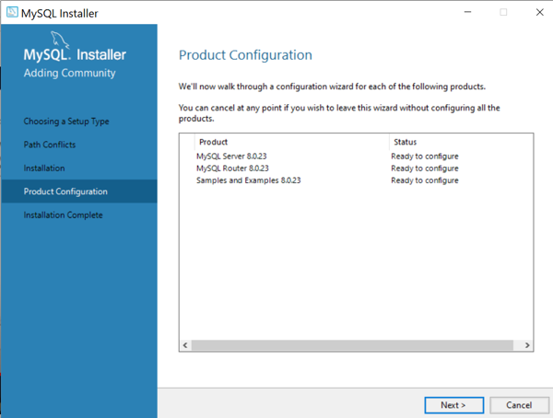

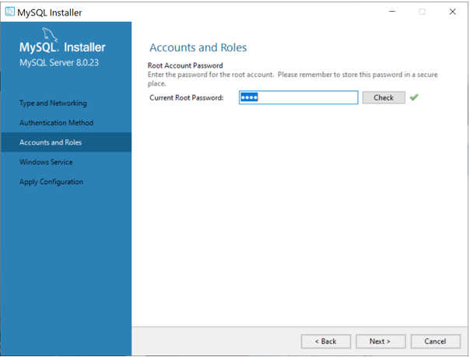

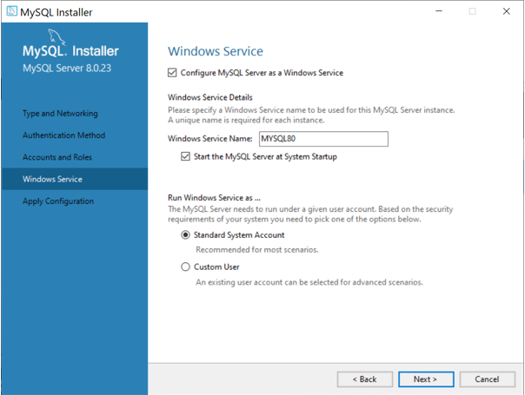

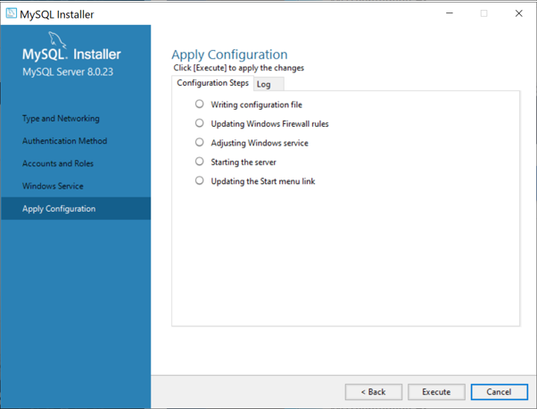

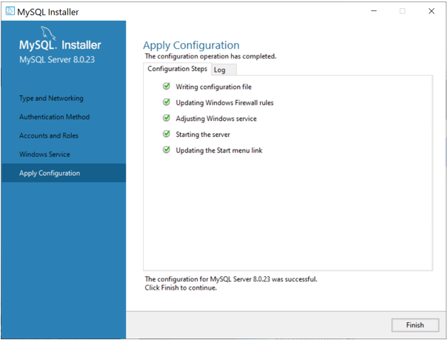

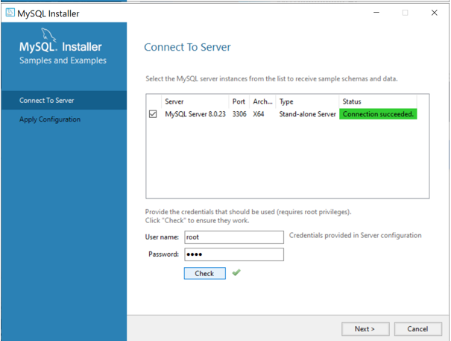

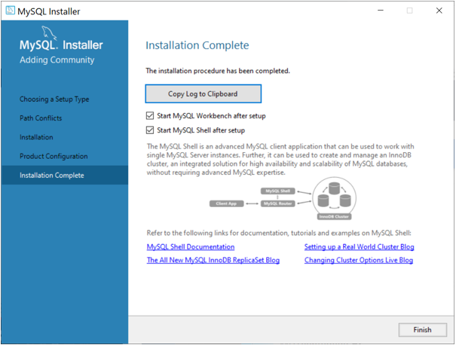

**Conclusion:**

In this assignment, we saw how to use MySQL Connector and Oracle connector /Python to integrate a MySQL database and Oracle database with our Python application. Along the way, we learned some programming best practices that are worth considering when it comes to establishing a connection, creating tables, and inserting and updating records in a database application.

**References:**

1. https://www.oracle.com/tools/downloads/sqldev-downloads.html
2. https://www.oracle.com/in/database/technologies/xe-downloads.html